Lab Practical #8:
Study & Survey of Institute organization network infrastructure.
Practical Assignment #8:
- Identify type of network in your institute. Draw a design of network in your institute (Any Lab/Floor/Building).
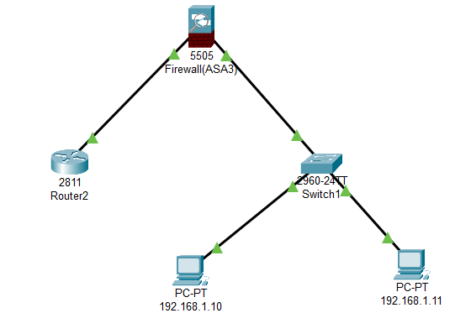

- List how many network devices and types of cable used and give its details.
- Firewall:
- A firewall is a network security system, implemented in hardware or software, that acts as a barrier between a trusted internal network and an untrusted external network, like the internet.
- It monitors and controls incoming and outgoing network traffic based on pre-defined security rules, allowing legitimate communication while blocking unauthorized access, malicious traffic, and potentially harmful applications to protect sensitive data and maintain network security.
- Router:
- A router is a device that connects different networks together and decides the best path for sending data using IP addresses.
- It works on layer 3 of the OSI model (Network Layer).
- It maintains a routing table.
- It is used in WAN.
- Available ports : 2/4/8.
- Switch:
- It is a telecommunication device which receives a message from any device connected to it and then transmits the message only to the device for which the message was meant.
- It works on layer 2 of the OSI model (Data Link Layer).
- It is also known as Multiport Bridge and has available ports: 4/8/16/24/48.
- At the time of initialization switch, it broadcasts frame to all nodes and after this process a memory table consisting of Port number and MAC Address of each device is maintained.
- After this it will unicast and multicast the message to the particular node.

